Name: Gaurav Amarnani. Class: CMPN DSE. OOPM Lab 02.
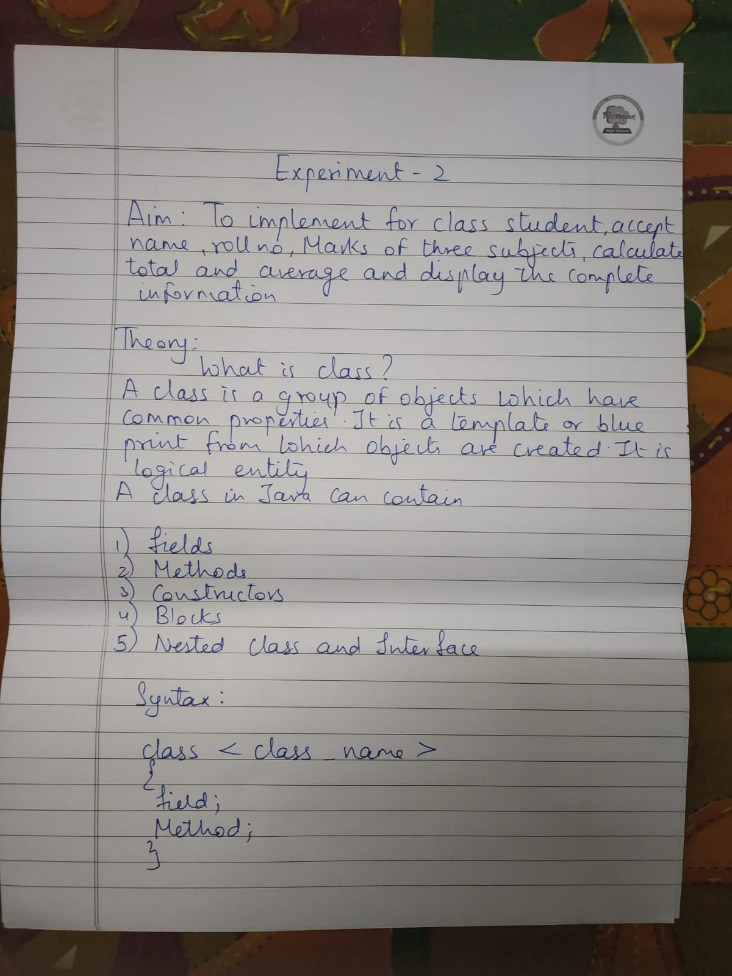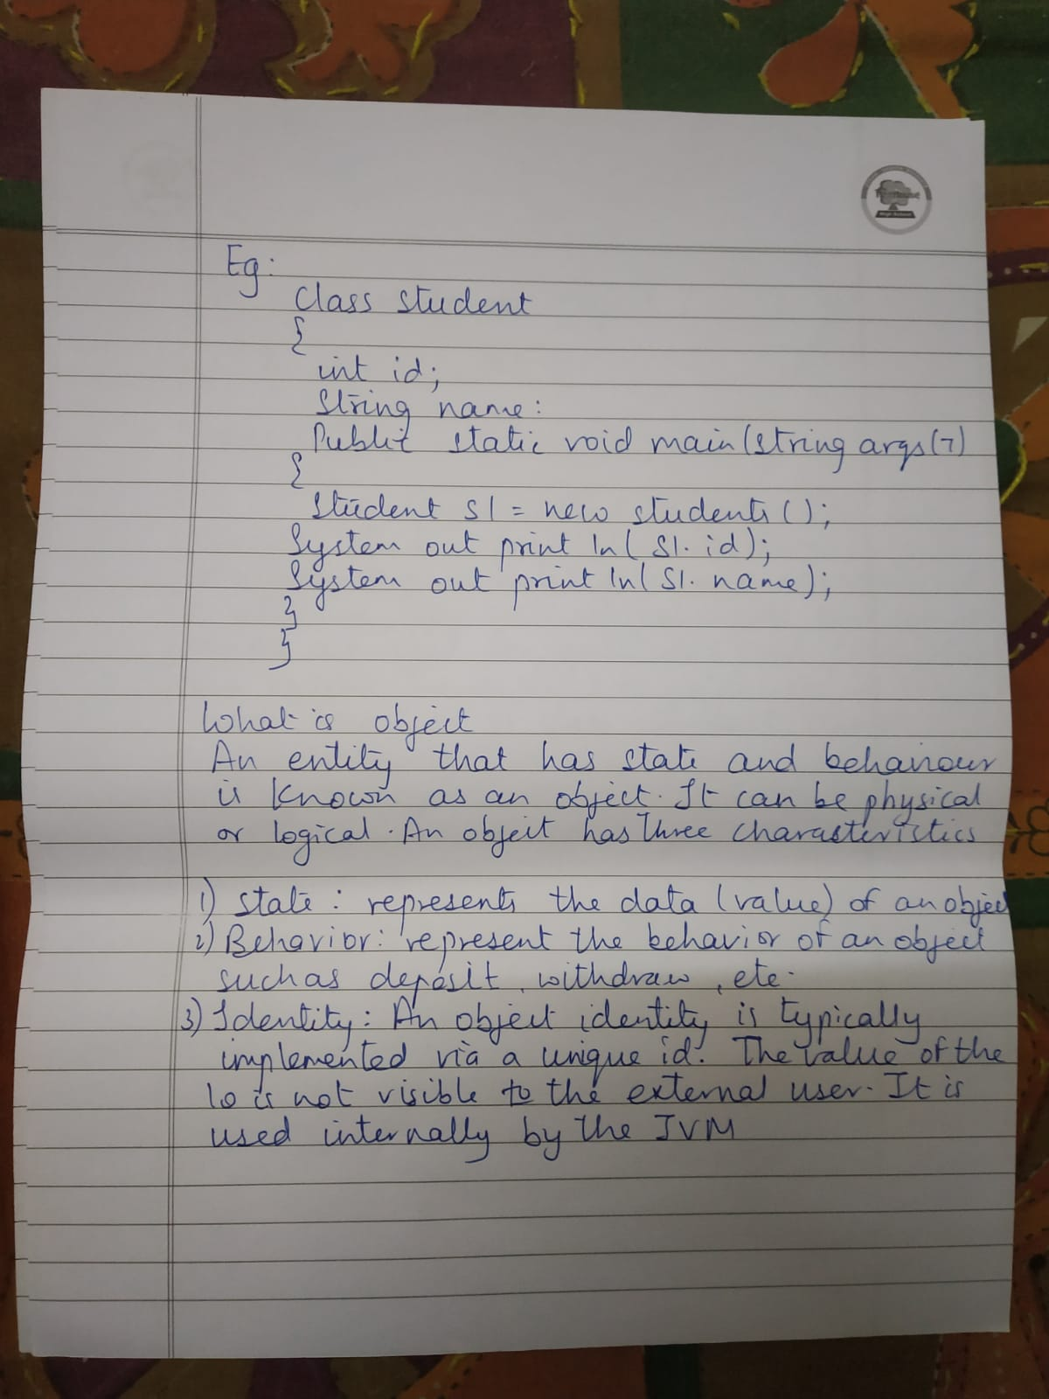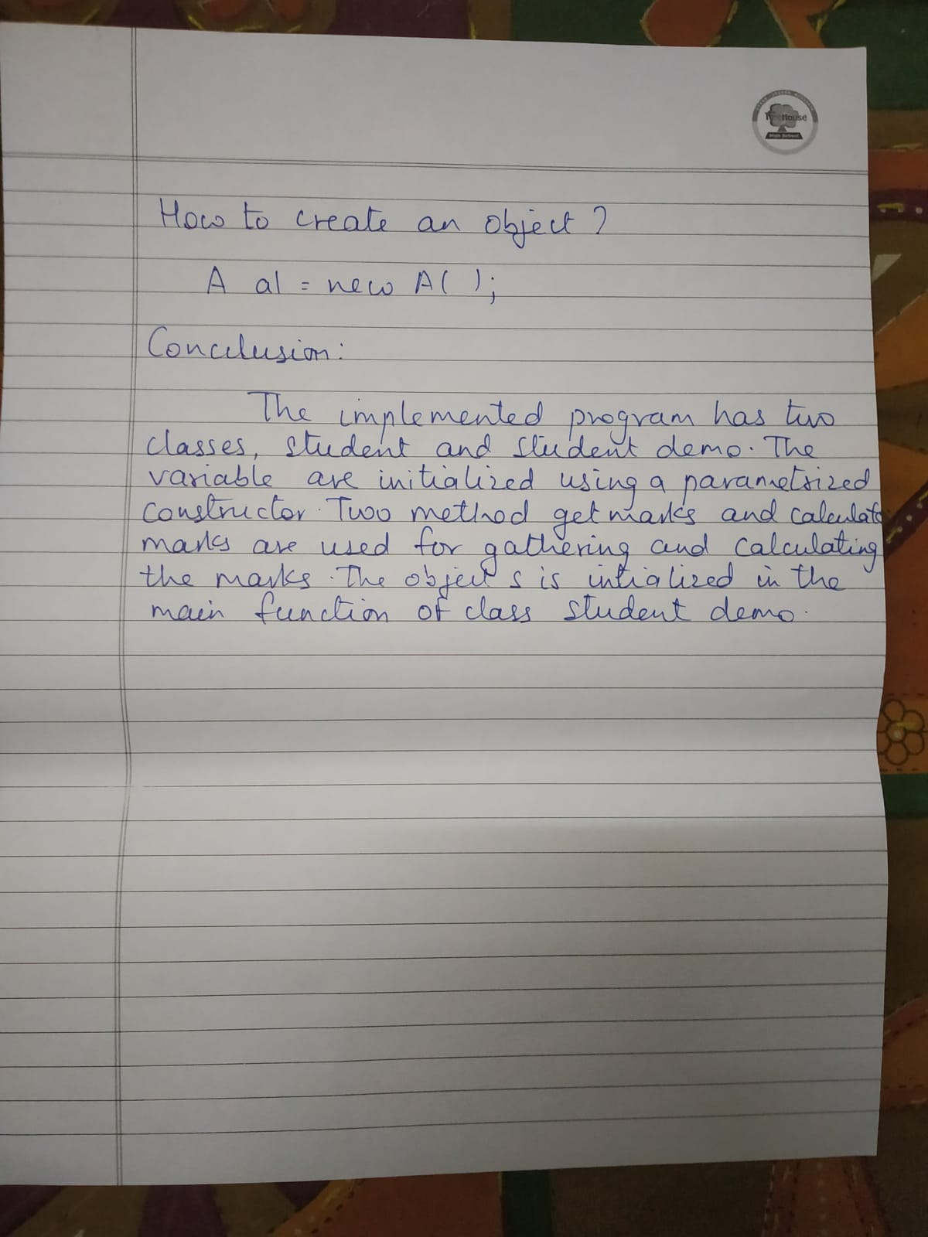

Programs:

Program 1: Write a program for class Student, accept name, roll no,marks of three subjects, Calculate total and display the complete information. use Constructor.

package com.byGaurav.lab02;

import java.util.HashMap;
import java.util.Scanner;
import java.util.Set;

import static java.lang.System.*;

/**
* @author Gaurav Amarnani.
*/

public class Student {

private String name;
private Integer rollNumber;
private HashMap<String, Integer> subjectMarks;

Student(String name, Integer rollNumber, HashMap<String, Integer> subjectMarks) {
this.name = name;
this.rollNumber = rollNumber;
this.subjectMarks = subjectMarks;
}

public static void main(String...args) {
Student student = takeInput();
out.println(student);
}

public static Student takeInput() {
Scanner scanner = new Scanner(in);
out.println("Enter Student Name: ");
String name = scanner.nextLine();
out.println("Enter Roll Number: ");
Integer rollNumber = scanner.nextInt();
HashMap<String, Integer> subjectMarks = new HashMap<>();
for(int i = 1; i < 4; i++) {
out.println("Enter Subject " + i + " name: ");
String subjectName = scanner.next();
out.println("Enter Subject " + i + " marks: ");
Integer marks = scanner.nextInt();
subjectMarks.put(subjectName, marks);
}
scanner.close();
return new Student(name, rollNumber, subjectMarks);
}

public Integer calculateMarks(HashMap<String, Integer> subjectMarks) {
Integer total = 0;
Set<String> keySet = subjectMarks.keySet();
for(String key : keySet)
total += subjectMarks.get(key);
return total;
}

@Override
public String toString() {
Integer totalMarks = calculateMarks(subjectMarks);
Integer averageMarks = totalMarks/3;
return "Name = " + name + ".\nRoll Number = " + rollNumber + ".\nSubjects = " + subjectMarks + ".\nTotal Marks = " + totalMarks + ".\nAverage Marks = " + averageMarks + ".";
}
}

Output:

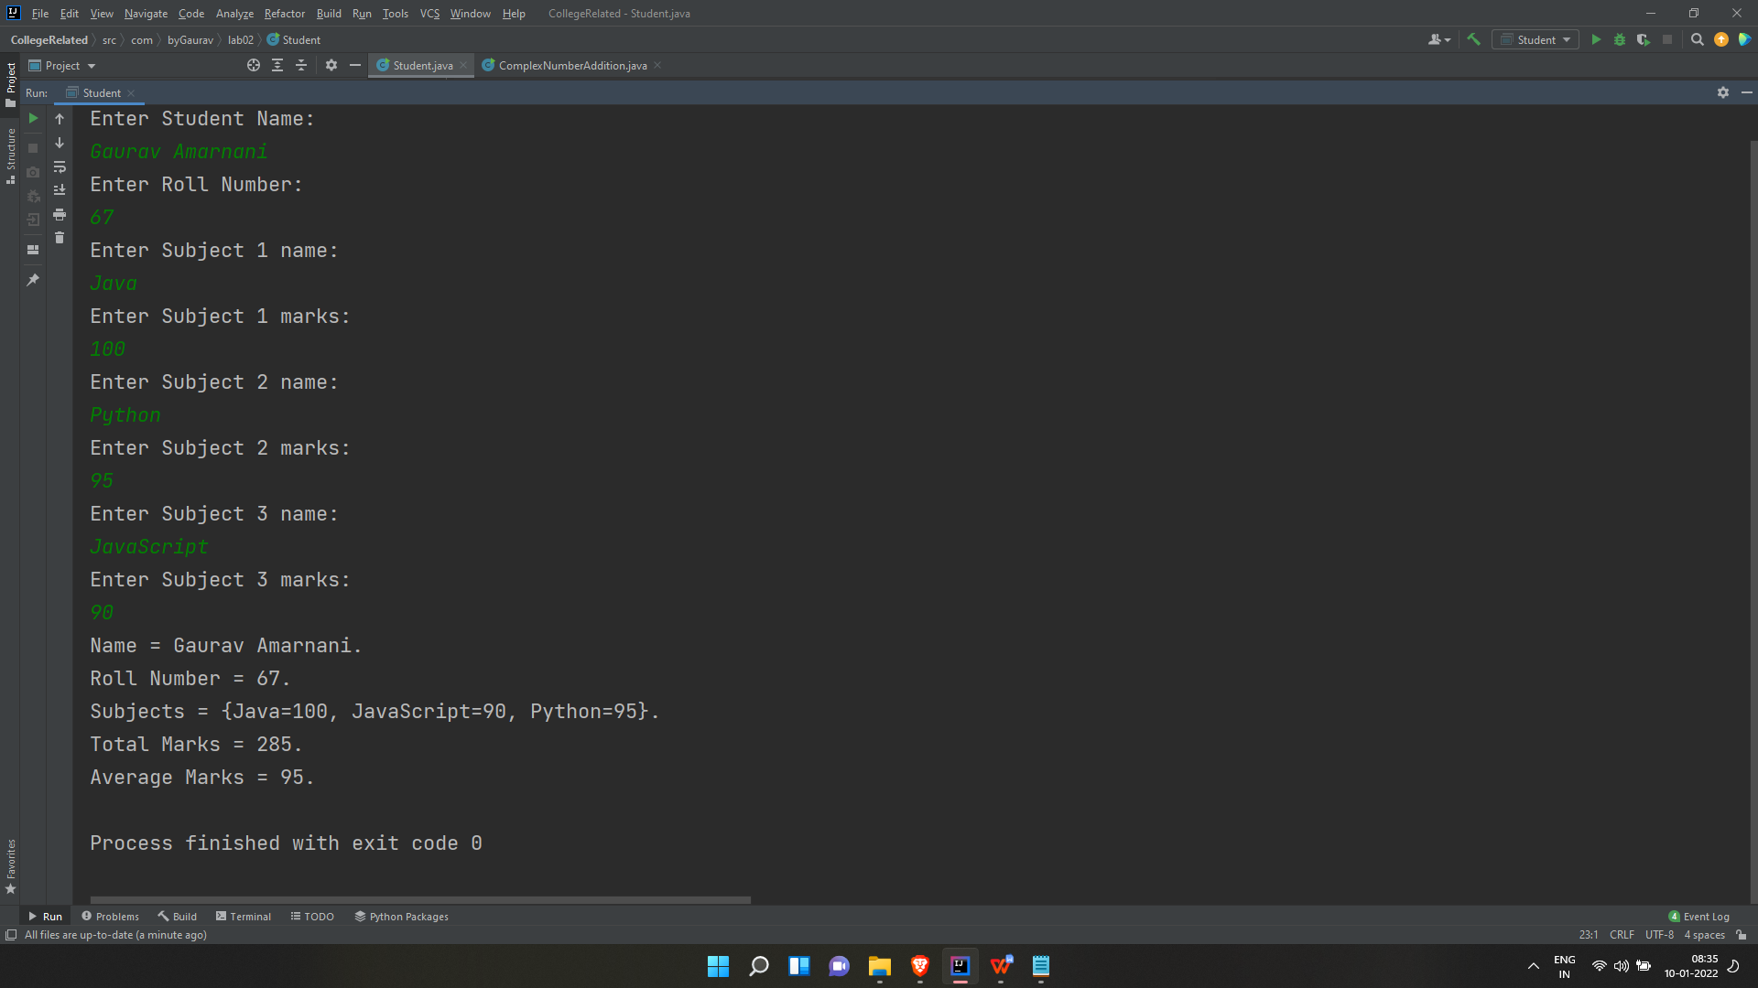

Program 2: Write a Program for Complex Number addition using Constructor.

package com.byGaurav.lab02;

import static java.lang.System.out;

/**
* @author Gaurav Amarnani.
*/

public class ComplexNumberAddition {
public static void main(String...args) {
Complex complex1 = new Complex(5, 10);
Complex complex2 = new Complex(7, 14);
Complex complex3 = new Complex(complex1, complex2);
out.println("Complex number 1 : " + complex1.getReal() + " + " + complex1.getImaginary() + "i");
out.println("Complex number 2 : " + complex2.getReal() + " + " + complex2.getImaginary() + "i");
out.println("Complex number 3 : " + complex3.getReal() + " + " + complex3.getImaginary() + "i");
}
}

class Complex {

private Integer real;
private Integer imaginary;

public Complex() {}

public Complex(Integer real, Integer imaginary) {
this.real = real;
this.imaginary = imaginary;
}

public Complex(Complex complex1, Complex complex2) {
this.real = complex1.real + complex2.real;
this.imaginary = complex1.imaginary + complex2.imaginary;
}

public Integer getReal() {
return real;
}

public void setReal(Integer real) {
this.real = real;
}

public Integer getImaginary() {
return imaginary;
}

public void setImaginary(Integer imaginary) {
this.imaginary = imaginary;
}
}

Output:

